SARAG
SOUTH YORKSHIRE ASBESTOS VICTIMS SUPPORT GROUP
WORKING FOR ASBESTOS VICTIMS ACCROSS SOUTH YORKSHIRE AND NORTH NOTTINGHAMSHIRE

Unit 37 Moorgate Crofts Business Centre, South Grove, Rotherham S60 2DH - 01709 360 672
www.saragasbestossupport.org sarag.asbestos@gmail.com

Sunday 19th November 2017 - Time: 7.30pm
Unite the Union Brass Band
presents
an evening of movie music and more
at The Niagara Centre, 9 Niagara Rd, Sheffield S6 1LU
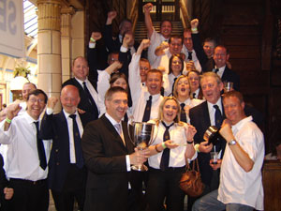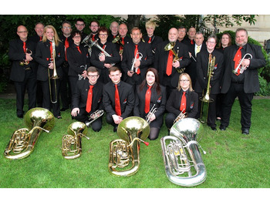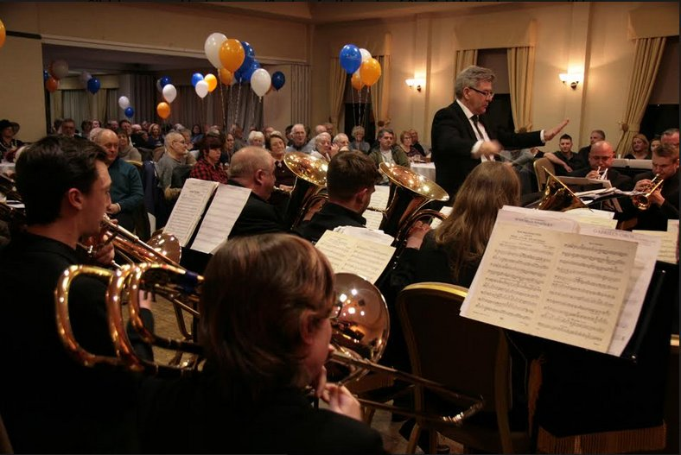
A Charity Concert in aid of SARAG
Doors & Bar open from 6.00pm

Pay on the door – but…
tickets are £6.00 if booked in advance
or £7.00 on the door
Tickets include free programme and free prize draw
Ring 01709 360 672 to book in tickets in advance
Also Raffle & Charity Auction on the night
SARAG Registered Charity number 1080365

